- Regulatory framework

Sustainability regulations have expanded significantly in recent years, and this trend is set to continue over the coming decade. Major pieces of legislation such as the EU Corporate Sustainable Reporting Directive (CSRD) and Corporate Due Diligence Directive (CSDDD) will not only intensify the need for large companies to understand, manage and disclose the impacts of their operations and supply chains, but will affect smaller companies as well, both inside and outside the EU. The impacts of this legislation can be direct, by bringing rental companies directly into their scope, or indirect, by requiring larger customers to comply, in which case these customers place reporting or compliance burdens onto rental companies in their supply chain.
This all makes it increasingly important for rental companies of all sizes (including SMEs) to have a reasonable understanding of current and upcoming sustainability legislation. While such legislation has previously been the preserve of specialist HSEQ (health, safety, environment and quality) experts or compliance officers, the breadth and depth of regulations such as CSRD and CSDDD requires co-ordination across companies. For example, both reporting and due diligence rules will require much greater control over and visibility of companies supply chains than has previously been seen.
The following table summarises when key legislation is likely to come into force for companies of different sizes. This is then followed by a short explanation of key legislation, together with more detailed explanations of topics of particular relevance to the equipment rental sector.
Applicability of EU Legislation
Legislation | Large rental companies | Small or medium rental companies
Non-Financial Reporting Directive (NFRD) | Already in force for large companies | Not in scope
EU Taxonomy | Already in force for large companies | SMEs in scope of CSRD must comply from 2026 (see below)
Corporate Sustainability Reporting Directive (CSRD) | From 2024, if previously covered by NFRD (listed companies with 500+ employees)  From 2025 if listed on regulated EU markets or meeting two of the following criteria:  - 250+ employees  - €40m+ revenue  - €20m+ balance sheet  From 2028 for non-EU companies with net turnover of €150m+ and at least one subsidiary or branch in the EU | From 2026, if listed on regulated EU markets and meeting two of the following criteria:  - Balance sheet total of €4m+  - Net turnover of €8m+  - Average of 50+ employees during the financial year  Other SMEs are not directly in scope, but are likely to be indirectly affected via large customers (such as data requirements to support Scope 3 emissions reporting)
Corporate Sustainability Due Diligence Directive (CSDDD) (predicted) | From 2027, EU companies of substantial size and economic power (proposed thresholds are 1000+ employees and €150m+ in net turnover worldwide)  Between 2027-28 other large EU companies (proposed thresholds are 500+ employees and €150m+ in net turnover worldwide)  From 2029, EU companies operating in defined high impact sectors with 250+ employees and a net turnover of €40m+ worldwide, plus non-EU companies in these sectors with a net EU-wide turnover of €40m+ | Not directly in scope, but may be indirectly affected via large customers

  - EU Taxonomy
The EU Taxonomy is a classification system establishing a list of environmentally sustainable economic activities. It is designed to play an important role in helping the EU to scale up sustainable investment and implement the European Green Deal. The Taxonomy provides companies, investors and policymakers with appropriate definitions for which economic activities can be considered environmentally sustainable.
Reporting under the EU Taxonomy classification system applies to companies subject to the NFRD or the CSRD. Based on current rules, large listed companies (more than 500 employees) will have to disclose to what extent the activities they carry out meet the criteria, however requirements on reporting and disclosure as expanded significantly under CSRD. Reporting under the EU Taxonomy may have benefits not only by demonstrating a company’s sustainability contribution (by disclosing how much economic activity is linked to EU environmental criteria), but also in terms of unlocking greater access to Green Financing. Concerned companies will have to make mandatory disclosures in their non-financial reporting (annual report or sustainability report), on the taxonomy alignment of three KPIs: turnover; capital expenditure; operation expenditure.
Companies should be aware that the rental sector has been included in the Taxonomy delegated act as a sector activity substantially contributing to the transition to circular economy. Investors and rental companies may therefore be able to include the rental part of portfolio under Taxonomy alignment. The ERA continues to lobby the EU to broaden the product scope of the rental model being recognized in EU taxonomy.
  - EU Non-Financial Reporting Directive (NFRD)
The NFRD currently requires certain large companies to disclose information about the way they assess and manage social and environmental issues, in order to assist investors, civil society organisations, consumers, policymakers and other stakeholders evaluate the non-financial performance of large companies. This scrutiny is intended to encourage these companies to develop a responsible approach to business.
NFRD defines rules on the disclosure of non-financial and diversity information by large companies (currently large public-interest companies with more than 500 employees). This coverage currently extends to approximately 11,700 large companies and groups across the EU, and includes listed companies, banks, insurance companies and other companies designated by national authorities as public interest entities.
Under NFRD, large companies must publicly disclose information related to environmental matters, social matters and treatment of employees, respect for human rights, anti-corruption and bribery and diversity on company boards (in terms of age, gender, educational and professional background)
In 2024, the Non-Financial Reporting Directive will be replaced in the EU by the significantly more comprehensive CSRD (see below). It will continue to have effect in countries not covered by CSRD, such as the UK, where it was transposed through the Companies, Partnerships and Groups (Accounts and Non-Financial Reporting) Regulations 2016 and the Companies Act 2006 (as amended). The UK is also considering the introduction of its own Sustainability Disclosure Standards (SDR).
  - EU Corporate Sustainability Reporting Directive (CSRD)

On 5 January 2023, the EU’s Corporate Sustainability Reporting Directive (CSRD) entered into force. The new rules aim to ensure that all stakeholders have access to the information they need to assess risks arising from sustainability issues across 10 different topical areas:
- Climate Change
- Pollution
- Water & Marine Resources
- Biodiversity & Ecosystems
- Resource Use & Circular Economy
- Own Workforce
- Workers in the Value Chain
- Affected Communities
- Consumers and End Consumers
- Business Conduct
The first companies will have to apply the new rules for the first time covering financial year 2024, with reports published in 2025, and will have to follow the European Sustainability Reporting Standards (ESRS), which are still passing through draft iterations as of late 2023, however the current drafts suggest a very comprehensive topical scope:
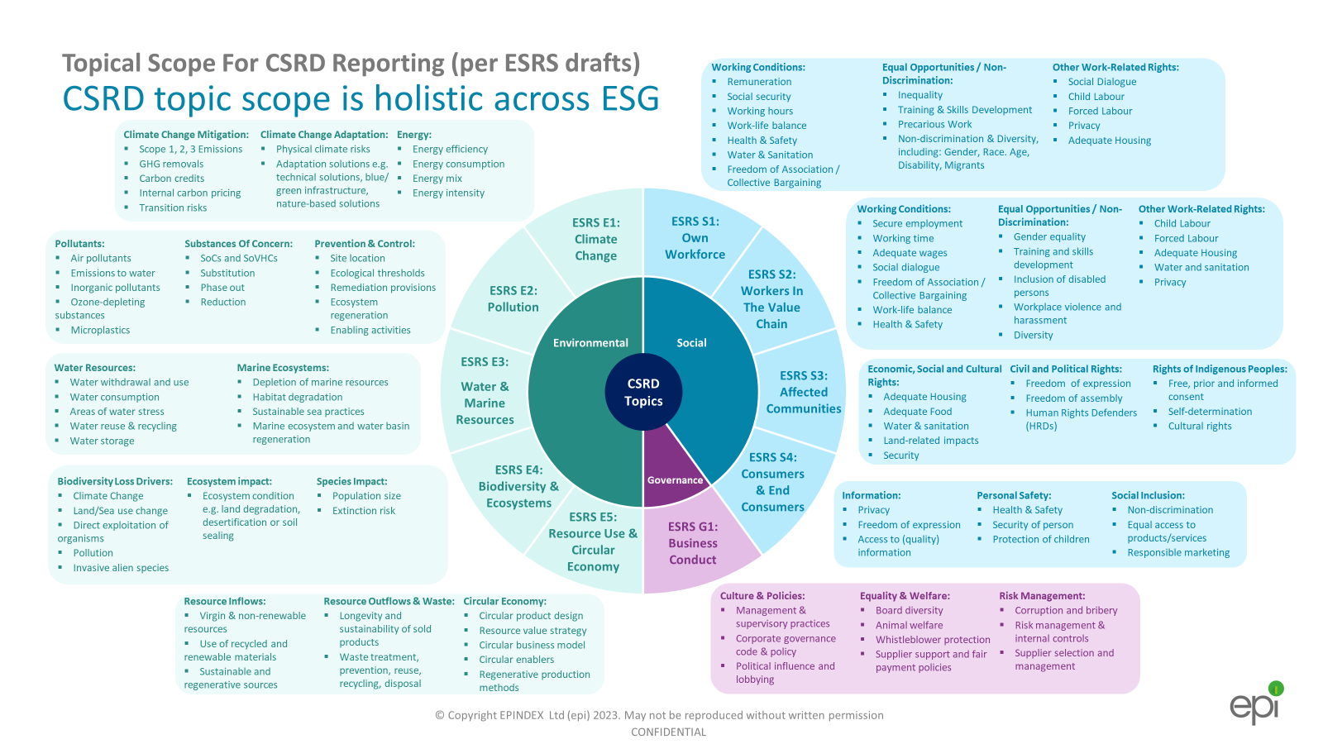
CSRD may also introduce mandatory rules for companies to have sustainability information audited by a third party to a level of limited or even reasonable assurance. In addition, the CSRD provides rules governing the digitalisation of sustainability information in company reports, such as mandating that reports are digitally tagged and machine readable.
Aside from its comprehensive topical scope, CSRD differs from other reporting standards such as the recent ISSB rules by requiring companies to not only report on how sustainability issues, such as climate change, impact their business but also how their operations in turn affect people and planet – a unique principle called ‘double materiality’. More information on double materiality is provided below, as this is a key concept in CSRD and one which rental companies are finding a challenging topic in their preparations for CSRD compliance.
The coverage of CSRD is extensive. Almost 50,000 companies are expected to be impacted by CSRD, covering some three quarters of business in the European Economic Area as well as a number of businesses based outside Europe.
Companies must publish their information in a dedicated section of their company management reports, usually included in their annual report. Current proposals are for CSRD to features mandatory assurance for reporting by an independent assurance service provider against sustainability reporting standards. This is to make sure information is accurate and reliable.
The challenge of collecting data to report on the required KPIs across CSRD’s 10 topical areas, to a level of quality, rigour and transparency that can pass external assurance is a significant challenge. However, rental companies that have started to implement the ERA’s Sustainability KPI guidelines will be well placed to further develop their reporting framework to meet the requirements of this legislation.

Double Materiality
Double materiality is a central concept in CSRD. It refers to the requirement for companies in scope of CSRD to determine which sustainability matters are relevant to them by considering both matters which are significant enough to affect the company, and matters where the company impacts other stakeholders or the wider world. In conducting this assessment, the company is thereby expected to consider both “financial materiality” and “impact materiality”, hence the term “double materiality”.
What threshold makes an issue, risk or opportunity ‘material’?
The European Sustainability Reporting Standards (ESRS) Draft states:
“A sustainability matter is material from an impact perspective if it is connected to actual or potential significant impacts by the undertaking on people or the environment over the short-, medium- or long-term.” ESRS para 49
“A sustainability matter is material from a financial perspective if it triggers or may trigger significant financial effects on undertakings, i.e., it generates or may generate significant risks or opportunities that influence or are likely to influence the future cash flows and therefore the enterprise value of the undertaking in the short-, medium- or long-term, but it is not captured or not yet fully captured by financial reporting at the reporting date.” ESRS para 53
Through the double materiality assessment, companies are expected to assess sustainability matters and identify material impacts, risks and opportunities on a case-by-case basis. Material topics, which are mandatory to report on, may therefore vary across the rental industry. There is not yet guidance from the EU on objective thresholds that make an issue, risk or opportunity material under either approach.
Are financial and impact materiality separate?
Although the two approaches are separate, there are important areas of overlap and it can be helpful to address both aspects of materiality together at some points.
For example, a common issue which is financially material to companies is carbon pricing. For example, the EU ETS (Emissions Trading System) was introduced in 2005 and for most of its life was set well below €20/tonne of CO2, limited to specific energy-intensive heavy industry sectors. Further plans could expand carbon pricing significantly to new sectors and companies (see, for example, the EU Carbon Border Adjustment Mechanism or CBAM). Due to this risk of increased compliance cost per tonne of CO2, companies with significant greenhouse gases embodied in their value chains, may view carbon emissions as both a wider societal and environmental impact, as well as a financial risk that exposes them to the risk of rising future carbon costs.
In another example, a company spills hazardous chemicals into a watercourse. This is would be an environmental impact, but could also be a financially-material risk if the company were at risk of being prosecuted by a regulator. It can therefore be seen that financial and impact materiality can be considered separately but are often inter-related, with financial materiality representing the ‘outside-in’ view of company sustainability while impact materiality represents the ‘inside-out’ view. This logic is shown in the direction of the arrows in the diagram below.
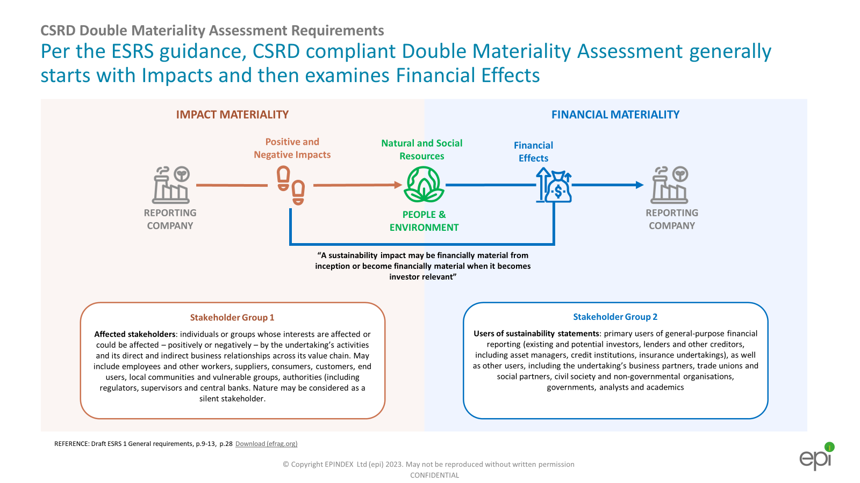
Why can double materiality be challenging for companies?
- Lack of familiarity in integrating ESG issues into existing risk management processes
- Lack of existing enterprise risk management (ERM) processes, particularly in SMEs (Small and Medium Enterprises)
- Unclear which issues may be material under either impact or financial materiality, without extensive modelling and analysis of unfamiliar scenarios
- Lack of data or widespread modelling expertise in certain topics, for example physical climate change hazards

Example: What issues are likely to be material to European rental companies?

While this Guide can only provide a general overview of legislation, and is not legal advice, there are certain topics that are highly likely to be material to companies purchasing and renting out construction equipment in Europe.

Impacts

- Greenhouse Gases and Air Pollution: Emissions of greenhouse gases and other pollutants to air.
- Land and Water Pollution: Actual or potential emissions of wastes or pollutants to water or land, especially REACH or RoHS
- Supply Chain Issues: Upstream supply chain impacts relating to climate change, pollution, waste, sustainable resource usage (including contribution to the circular economy), workforces, human rights, community rights, governance issues including Anti-Bribery and Corruption.

Risks

- Physical Climate Change Risks: Physical hazards of climate change if the company is especially exposed (e.g. its offices or depots are within an area of high flood risk)
- Carbon Pricing: Carbon pricing. As noted above, industries which currently have high emissions are exposed to implementation of wider or stricter carbon pricing rules, such as the proposed EU Carbon Border Adjustment Mechanism (CBAM) which will target imports of materials such as steel, aluminium and hydrogen.

Opportunities

- Demand for Sustainable Rental Services: Changing, or additional, client requirements or industry growth due to sustainability factors. For example, the focus on the construction sector and circularity in the EU’s Circular Economy Action Plan, which could increase demand for equipment used in site waste management, insulation installation and other specific trades.

Rental companies will find it helpful to engage with the ERA’s Sustainability KPIs Framework (erarental.org/wp-content/uploads/2023/06/ERA-Sustainability-KPIs-2.0-Guidance-Framework.pdf). This provides rental companies with an extremely clear framework for selecting relevant KPIs and sustainability measurements, as well as guidance on how to implement measurement and reporting through a business. Adopting the ERA’s Sustainability KPI’s Framework can therefore assist rental companies accelerating their sustainability measurement and management to take an early lead in complying with the requirements of CSRD.

  - EU Corporate Sustainability Due Diligence Directive (CSDDD)

In February 2022, the European Commission adopted a proposal for a Corporate Sustainability Due Diligence Directive (CSDDD). The proposed directive aims to foster sustainable and responsible corporate behaviour throughout the global value chains of companies within its coverage, recognising that many of these entities will play a vital role in building a sustainable economy and society. Companies will be required to carry out assessment of their operations and value chains, identify and, where necessary, prevent, end or mitigate adverse impacts of their activities.
The directive covers a range of sustainability impacts, including human rights, such as forced labour, child labour and workforce wellbeing as well as environmental issues such as climate change, pollution and biodiversity loss. For businesses, these new rules will bring legal certainty and a level playing field across the EU, while for consumers, investors and other stakeholders they will provide more transparency. The CSDDD rules will apply to the following companies and sectors:
- EU companies:
  - Group 1: All EU limited liability companies of substantial size and economic power (with 500+ employees and €150 million+ in net turnover worldwide).
  - Group 2: Other limited liability companies operating in defined high impact sectors, which do not meet both Group 1 thresholds, but have more than 250 employees and a net turnover of €40 million worldwide and more. For these companies, rules will start to apply 2 years later than for Group 1.
- Non-EU companies active in the EU with turnover threshold aligned with Group 1 and 2 generated in the EU. Small and medium-sized enterprises (SMEs) are not directly in the scope of this proposal. This proposal applies to the company’s own operations, their subsidiaries and their value chains (direct and indirect established business relationships).
In order to comply with their duties under this directive, companies must:
- Integrate due diligence into policies
- Identify actual or potential adverse human rights and environmental impacts
- Prevent or mitigate potential impacts
- Bring to an end or minimise actual impacts
- Establish and maintain a complaints procedure
- Monitor the effectiveness of the due diligence policy and measures
- Publicly disclose their efforts on due diligence.
The proposed CSDDD would cover a broad range of Human Rights and Environmental risks:
Human Rights Risks | Environmental Risks
- Child Labour  - Forced Labour  - Health & Safety  - Labour Rights  - Discrimination  - Adequate Wages  - Environmental Pollution  - Land Rights  - Torture/inhumane treatment  - Right to life and security  - Right to privacy  - Freedom of thought and religion  - Adequate standard of living  - Adequate housing for workers  - Self-determination  - Human trafficking | - Mercury (Minamata convention)  - Waste disposal (Basel convention)  - POPs (Stockholm convention)  - Climate Change & Greenhouse Gas (GHG) reduction  - Biodiversity  - Air, water, soil pollution  - Ecosystem degradation  - Deforestation  - Waste & hazardous substances  - Ozone layer depletion  - UNCLOS (Marine Activities)  - Aarhus convention  - Transboundary watercourses

The CSDDD is a substantial piece of legislation and will place significant challenges on companies. Those in scope will need to take appropriate measures depending on:
- the severity and likelihood of different impacts they assess;
- the measures available to the company in the specific circumstances; and
- the need to set priorities.
National administrative authorities appointed by Member States will be responsible for supervising these new rules and may impose fines in case of non-compliance. In addition, victims will have the opportunity to take legal action for damages that could have been avoided had appropriate due diligence measures been in place.
The proposal also introduces directors’ duties to set up and oversee the implementation of due diligence and to integrate it into the corporate strategy. While discharging their duty to act in the best interest of the company, directors will need to take into account the human rights, climate change and environmental consequences of their decisions.
Furthermore, under Article 15 of the proposed directive, Group 1 companies will be required to adopt a plan that ensures their business is compatible with limiting global warming to 1.5°C, in line with the Paris Agreement, essentially mandating Net Zero targets and plans for all in scope companies.
A number of similar national due diligence laws have already been enacted or are being enacted, with the most notable being the French and German laws as detailed below:
  - Relevant national laws
The French ‘Devoir de Vigilance’ (Duty of Vigilance)
The French Corporate Duty of Vigilance Law, in force since 2017, places a duty on large companies in France to identify and prevent risks to human rights and the environment that could occur as a result of their business activities. These activities can include those of the company itself, of their suppliers or subcontractors, as well as subsidiary companies they control. Companies are required to create, implement and disclose vigilance plans for which they can be held accountable. The law is designed to improve the corporate social responsibility programmes of the companies in scope, as well as to aid the victims of any sustainability impacts in achieving justice.
German Supply Chain Due Diligence Act (SCDDA or LkSG in German)
Germany passed a supply chain due diligence act in 2021, requiring companies to comply with new due diligence obligations in regard to their suppliers. These rules also capture foreign companies with German subsidiaries or German branches with more than 1,000 employees in Germany. Companies are required to establish processes to identify, assess, prevent and remedy violations of human rights and the environment in their wider value chain – with the primary focus on Tier 1 suppliers, but they may also be required to act on issues where they have “substantial knowledge” of potential violations further upstream in the supply chain.
Companies with at least 3,000 employees must comply by 1 January, 2023, and companies with at least 1,000 employees by 1 January 2024. Fines of up to 2% of global annual turnover may be levied at large firms in breach of the act.
Reporting and Due Diligence Summary
It can be seen that both general disclosure and due diligence requirements are becoming significantly tougher in Europe and are likely to have significant impacts on the rental industry.
If a CSRD program has not already been mobilised within the company, rental companies operating in the EU should work with legal or compliance experts to determine if CSRD applies to them and if so, mobilise a program to conduct a gap analysis of their CSRD readiness. In most cases, companies will need to:
- redevelop their materiality processes to incorporate double materiality assessment,
- develop new sustainability data controls and reporting capability to report on required KPIs for material topics, and
- develop a new annual reporting structure and process to meet the CSRD requirements.
Large rental companies also need to consider the potential impacts of the CSDDD. Although CSDDD legislation is currently at proposal stage, it is expected by any experts to pass without major changes to the substance of the current text.
For companies in scope, the CSDDD will mean enhancements to due diligence procedures, even for companies currently complying with the French or German due diligence laws, requiring not only a wider topical scope of potential and actual harms, but also a potentially deeper “value chain” scope for risk assessment.
Whilst SME companies are unlikely to be in the direct scope of CSDDD, being aware of the requirements faced by their larger customers will allow them to be prepared to anticipate potential data requests or begin to mitigate potential harms for which a customer may flag them or their extended supply chain.
As noted above for CSRD, the ERA’s Sustainability KPI Framework is helpful to rental companies seeking to ensure they are compliant with CSDDD ahead of implementation.

  - EU Batteries Regulation
The forthcoming EU Batteries Regulation due diligence requirements cover cobalt, lithium, nickel and natural graphite, and requires from August 2025 that companies in scope of the regulation establish a strong due diligence system that includes:
- Creating, implementing and monitoring a battery due diligence policy;
- Establishing a chain of custody or traceability system;
- Assessing and managing both environmental and social risks in the battery value chain, and having their due diligence systems third-party verified;
- Establishing a grievance process.
Companies in scope are manufacturers, importers and distributors of batteries, so this will include European vehicle and equipment manufacturers who import batteries for use in their products or who manufacture batteries themselves within the EU. Rental companies who purchase batteries from retailers in the EU should not be subject to additional duties.
There are a number of other provisions in the Batteries Regulation, that can be of benefit to rental companies and their customers, such as:
- The requirement for portable consumer batteries to be removable and replaceable from appliances (such as power tools, for example) by the end-user (from August 2027)
- The requirement for large batteries to have a carbon footprint declaration (from 2026 at the earliest).
- Batteries will have to fulfil minimum performance and durability requirements set out by secondary legislation.
- Every large battery will have a digital passport containing all required information about the lifetime of the battery.
- There are also provisions on restriction of substances in batteries, with similar effect on end-users such as described below for REACH.

  - REACH Legislation
REACH stands for the Registration, Evaluation, Authorisation and Restriction of Chemicals, and is one of the key pieces of EU legislation protecting human health and the environment from the effects of chemicals, dating from 2006. REACH requires all companies manufacturing within, or importing into, the EU, more than one tonne of a chemical each year, to register the substances with the European Chemical Agency (ECA).
There are additional restrictions around chemicals known as Substances of Very High Concern (SVHCs) such as carcinogens and other toxins, and the ECA must be notified if these chemicals are present in articles at a concentration of greater than 0.1% by mass.
REACH also requires companies to communicate information about risk assessments and management up and down their supply chains. This means there is established practice and guidance on matters such as how companies should record relevant data in safety sheets to be passed onto downstream users, and how upstream suppliers of substances can be informed of possible exposure or release mechanisms by which their substances could cause a hazard.
This means that for rental companies, REACH will be relevant where the company is a user of the chemical substances covered by the legislation. Companies will provide user sheets explaining which substances can be found in different equipment components, what hazards they can cause and if personal protective equipment is needed to handle or work with that component. For example, 1,2-Dimethoxyethane is a toxic chemical which is present in some vehicle components.
For rental companies, the relevance of REACH is primarily in terms of their supply chain due diligence. The manufacturers, importers and distributors of equipment, parts and consumables will be responsible for complying with their duties under REACH, but rental companies coming in scope of forthcoming due diligence legislation should be aware of the potential for negative impacts through the value chain.
  - Low-Emission and Ultra Low Emission Zones
Low Emissions Zones (LEZ) and Ultra-Low Emission Zones (ULEZ) are areas legally designated to restrict the operation of polluting vehicles or machinery in order to control emissions and improve air quality. LEZ and ULEZ have become widely established across Europe, for example the ‘milieuzone’ in the Netherlands, the ‘umweltzonen’ in Germany and the ‘Zone à Circulation Restreinte’ (ZCR) in France.
The exact rules governing LEZ and ULEZ in different countries and regions can differ significantly. Some areas enforce and absolute ban on certain types of vehicles (for example, diesel vehicles or vehicles over a certain age). Some areas require vehicles to display information about their emissions.
For example, Germany has had a national framework of low emission zones since 2007, which affect all vehicles other than motorbikes and requires vehicles travelling into the zones to display stickers showing their emissions classes. All diesel vehicles built before 2000 are banned. This framework has then been applied to multiple zones (73 zones, as of 2015). A number of German cities have additional restrictions on vehicles within their boundaries, such as prohibiting HGVs from entering the city centre or requiring all diesel vehicles to reach Euro 6 standard for emissions.
In the UK, the city of London has gone further and expanded its Ultra-Low Emission Zone to the entire city in 2023. Cars or vans which do not meet minimum standards (Euro 6 for diesel and Euro 4 for petrol) will have to pay a charge of £12.50 per day, or will be fined. This is in addition to the Congestion Charge of £15 which applies to most vehicles entering the centre of London, and the LEZ penalty of £100 for commercial vehicles entering Greater London which do not meet minimum emission standards.
Due to the variety of rules in different areas, it is important for operators to be aware of specific local constraints and to plan accordingly. More information is available online, for example at www.urbanaccessregulations.eu.
The business case for going beyond compliance
As well as regulatory compliance, there are many other benefits to companies who engage proactively with sustainability. It is well established that strong management of sustainability risks and impacts such as climate change, pollution, waste and social issues means a company will be viewed positively by investors, staff, customers and suppliers. In recent years, this benefit has extended into the realm of financing. According to a report by Moody’s credit agency, the global issuance of green, social, sustainability and sustainability-linked bonds will grow by 10% in 2023 from 2022 to approximately $950 billion.
Case Study: Green Financing
European equipment rental company Riwal was able to secure preferential finance rates on a €300m Revolving Credit Facility (RCF) by signing up to a number of sustainability commitments. The RCF is provided by a syndicate of European banks, including ABN AMRO, Commerzbank, Deutsche Bank, ING and Rabobank. The interest rate on this facility depends on the company’s performance against a number of sustainability metrics.
The metrics come from Riwal’s ‘Sustainability 2025’ strategy, and include:
- Increasing the number of sustainable products
- Reducing solid waste
- Increasing the company’s Ecovadis score from Silver to Platinum level
- Reducing Riwal’s overall carbon footprint.
This is a strong example of how financial service companies are increasingly keen to associate their lending and investment practices with more sustainable companies, and how rental companies can see additional benefits from their sustainability action.
Further Legislation
In addition to the legislation described above, there are also other national laws in place that we are not able to cover in this guide, such as the Norwegian Transparency Act and the Netherlands Child Labour Due Diligence Act, and further legislation is developing around national corporate carbon disclosure (such as SDR in the UK), other areas of the EU Green Deal such as circular economy, and various modern slavery legislation (most immediately at country level, as well as in the longer term at EU level). For example:
- Alternative Fuels Infrastructure Regulation – this aims to ensure there is sufficient charging infrastructure and refuelling stations in Europe. It does not specifically cover machinery yet, but certain provisions will be helpful to rental companies planning to electrify their delivery fleets – such as the requirement for EU Member States to ensure there are electric charging stations every 60km along main transport corridors by 2025.
- Energy Taxation Directive Revision - this revision sets minimum tax rates and a set of rules to ensure that fuels are taxed according to their energy content and sustainability. Tax exemptions for air and sea travel and home heating are to be phased out.
- Ecodesign for Sustainable Products Regulation – a framework to regulate product groups with requirements on product durability, reusability, upgradability, reparability and other aspects of the circular economy.
- EURO 7 and CO₂ standards on cars and vans – these standards reduce the emission limits for buses and trucks, but leave the limits for cars and vans unchanged from Euro 6. Emissions from tyre and brake wear are included for the first time, as are Nitrous Oxide (N₂O) emissions. These specific emission limits do not apply to Non-Road Mobile Machinery (NRMM) which is covered by the NRMM Regulation finalised in 2016 with the ‘Stage V’ standard applicable to all engines used in NRMM over 56kW and all compression ignition diesel engines.
Overall, the regulatory environment around sustainability is currently dynamic and it is important for rental companies to invest time to understand the specific implications of current and emerging legislation for their specific entities, both in terms of direct compliance, and to be prepared to support indirect requirements from larger customers who may be in scope for legislation such as CSRD and CSDDD.

https://eur-lex.europa.eu/legal-content/EN/TXT/?toc=OJ%3AL%3A2022%3A322%3ATOC&uri=uriserv%3AOJ.L_.2022.322.01.0015.01.ENG
https://eur-lex.europa.eu/legal-content/EN/TXT/?uri=CELEX%3A52022PC0071
https://www.pwc.ch/en/images/ch-blog-graphics-CSDDD-2.jpg
https://ec.europa.eu/sustainable-finance-taxonomy/
https://erarental.org/publications/era-position-on-the-eu-taxonomy-for-sustainable-activities/
https://www.gov.uk/guidance/uk-sustainability-disclosure-standards
https://www.efrag.org/Assets/Download?assetUrl=%2Fsites%2Fwebpublishing%2FSiteAssets%2FED_ESRS_1.pdf
https://www.legifrance.gouv.fr/jorf/id/JORFTEXT000034290626/
https://www.bundestag.de/dokumente/textarchiv/2021/kw23-de-lieferkettengesetz-845608
https://eur-lex.europa.eu/legal-content/EN/TXT/PDF/?uri=CELEX:32023R1542
https://www.whitecase.com/insight-alert/new-eu-batteries-regulation-introducing-enhanced-sustainability-recycling-and-safety#:~:text=The%20new%20rules%20will%20apply,portable%2C%20independent%20of%20their%20origin.
https://eur-lex.europa.eu/eli/reg/2006/1907
https://echa.europa.eu/communication-in-the-supply-chain-infographic
https://www.renaultgroup.com/wp-content/uploads/2023/06/fiche-master-x62-0123-eng.pdf
ESG Credit and Sustainable Finance | Moody's (moodys.com)
https://eur-lex.europa.eu/legal-content/EN/TXT/?uri=CELEX%3A52021PC0559
https://taxation-customs.ec.europa.eu/green-taxation-0/revision-energy-taxation-directive_en
https://commission.europa.eu/energy-climate-change-environment/standards-tools-and-labels/products-labelling-rules-and-requirements/sustainable-products/ecodesign-sustainable-products-regulation_en
https://www.consilium.europa.eu/en/press/press-releases/2023/12/18/euro-7-council-and-parliament-strike-provisional-deal-on-emissions-limits-for-road-vehicles/
https://eur-lex.europa.eu/legal-content/EN/TXT/?uri=CELEX:32016R1628

